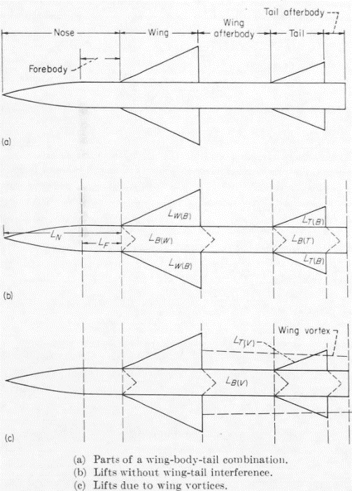
There are seven principal components to consider for a double stage-rocket:
- Lift on nose, including forebody, $L_{N}$
- Lift on wing in presence of body, $L_{W\left(B\right)}$
- Lift on body due to wing, $L_{B\left(W\right)}$
- Lift on tail in presence of body, $L_{T\left(B\right)}$
- Lift on body due to tail, $L_{B\left(T\right)}$
- Lift on tail due to wing-tip vortices, $L_{T\left(V\right)}$
- Lift on wing afterbody due to wing vortices, $L_{B\left(V\right)}$
These methods are based on the slender-body theorem, which assumes that flow is mostly in the longitudinal direction.
The wing is defined as two-half wings joined together.
These processes are limited to low angles of attack, negative sweep (CCW) at the leading and positive sweep (CW) at the trailing edge, and uniform body diameter.
The seven lift components can be determined with the following equations (Eq. 50-56):  $${\left(C_{L}\right)}_{N}=K_{N}{\left(C_{L_{α}}\right)}_{N}α$$  $${\left(C_{L}\right)}_{W\left(B\right)}=\left[K_{W\left(B\right)}α+k_{W\left(B\right)}δ_{W}\right]{\left(C_{L_{α}}\right)}_{W}$$  $${\left(C_{L}\right)}_{B\left(W\right)}=\left[K_{B\left(W\right)}α+k_{B\left(W\right)}δ_{W}\right]{\left(C_{L_{α}}\right)}_{W}$$  $${\left(C_{L}\right)}_{T\left(B\right)}=\left[K_{T\left(B\right)}α+k_{T\left(B\right)}δ_{T}\right]{\left(C_{L_{α}}\right)}_{T}\left(\frac{S_{T}}{S_{W}}\right)$$  $${\left(C_{L}\right)}_{B\left(T\right)}=\left[K_{B\left(T\right)}α+k_{B\left(T\right)}δ_{T}\right]{\left(C_{L_{α}}\right)}_{T}\left(\frac{S_{T}}{S_{W}}\right)$$  $${\left(C_{L}\right)}_{T\left(V\right)}=\frac{{\left(C_{L_{α}}\right)}_{W}{\left(C_{L_{α}}\right)}_{T}\left[K_{W\left(B\right)}α+k_{W\left(B\right)}δ_{W}\right]i\left(s_{T}-r_{T}\right)}{2πA_{T}\left(f_{W}-r_{W}\right)}$$  $${\left(C_{L}\right)}_{B\left(V\right)}=-\frac{4Γ_{m}}{S_{W}V_{∞}}\left[\frac{\left(f_{W}^{2}-r_{W}^{2}\right)}{f_{W}}-f_{T}+\frac{r_{T}^{2}}{\sqrt{f_{T}^{2}+r_{T}^{2}}}\right]$$ | The six centers of pressure can be determined with the following equations (Eq. 75-81):  $${\overline{l}}_{N}=l_{S}-\frac{V_{s}}{πr_{N}^{2}}$$  $${\overline{l}}_{W\left(B\right)}=l_{W}+{\left(\frac{\overline{x}}{c_{r}}\right)}_{W\left(B\right)}{\left(c_{r}\right)}_{W}$$  $${\overline{l}}_{B\left(W\right)}=l_{W}+{\left(\frac{\overline{x}}{c_{r}}\right)}_{B\left(W\right)}{\left(c_{r}\right)}_{W}$$  $${\overline{l}}_{T\left(B\right)}=l_{T}+{\left(\frac{\overline{x}}{c_{r}}\right)}_{T(B)}{\left(c_{r}\right)}_{T}$$  $${\overline{l}}_{B(T)}=l_{T}+{\left(\frac{\overline{x}}{c_{r}}\right)}_{B(T)}{\left(c_{r}\right)}_{T}$$  $${\overline{l}}_{T(V)}={\overline{l}}_{T\left(B\right)}$$

These can be used to determine a combination center of pressure in the following way (Eq. 82):
$${\overline{l}}_{C}=\frac{\sum{{\overline{l}}_{i}{\left(C_{L}\right)}_{i}}}{\sum{{\left(C_{L}\right)}_{i}}}$$
These methods predict lift-curve-slope within 10% for a variety of configurations and predict total center of pressure within 2% of the body length (5.7 cm for half-stack, 8.9 cm for full-stack)

